AGROCARE - AGENTIC AI MODEL

Executive Summary :
AgroCare is an advanced smart agriculture support platform designed to enhance farming practices through AI-driven solutions. Leveraging cutting-edge technologies, AgroCare provides farmers with data-driven insights for improving crop yield, optimizing irrigation, managing disease outbreaks, and ensuring sustainable farming practices.
At the core of AgroCare is a modular Agentic AI system that includes multiple intelligent agents specialized in distinct agricultural tasks. These agents are designed to work collaboratively, offering personalized crop recommendations, weather forecasts, irrigation advice, disease detection, and expert consultation. The platform also integrates with real-time external data sources like weather APIs and geolocation services to ensure accuracy and up-to-date recommendations.
Agrocare’s architecture consists of four layers:
- Frontend Layer: A user-friendly interface (React/Streamlit) allowing farmers to interact with the platform, input data, and receive insights.
- MCP Host (Master Control Program): An orchestrator managing task delegation and coordination across various agents.
- Agent Layer: AI agents dedicated to specific tasks such as crop selection, disease detection, and irrigation planning, powered by machine learning models and external APIs.
- Tool & Memory Layer: A set of supporting tools and memory systems for storing context, managing task execution, and integrating external services like weather or map APIs.
AgroCare is poised to revolutionize farming by providing practical, AI-driven solutions for farmers, improving crop management, and increasing productivity while ensuring sustainable agricultural practices.

Solution Overview :

AgroCare is an AI-powered platform designed to address the challenges faced by modern farmers by providing data-driven solutions for crop management, irrigation, disease control, and overall farm optimization. The platform leverages Agentic AI, a modular and scalable architecture, enabling personalized recommendations and intelligent task automation for every stage of the farming cycle.
Core Features and Benefits:
- Crop Recommendation System:
  - Uses machine learning models and environmental data (soil, climate, etc.) to recommend the most suitable crops for a given region and soil type, optimizing yield and reducing wastage.
- Irrigation Management:
  - Offers real-time irrigation suggestions based on weather forecasts and soil moisture data, helping farmers conserve water while ensuring crops receive optimal hydration.
- Weather Forecast Integration:
  - Provides accurate, real-time weather data for the farm’s location, enabling farmers to plan for adverse conditions like storms, droughts, or frost, and take preventive actions.
- Disease Detection & Prevention:
  - Uses image recognition technology to analyze crop images for signs of diseases or pests, alerting farmers early to prevent crop loss and reduce pesticide usage.
- Expert Consultation & Support:
  - Connects farmers with agricultural experts who can offer advice, answer questions, and help troubleshoot issues through the platform’s integrated chat feature.
- Cold Storage & Market Location Suggestions:
  - Uses geolocation data to suggest nearby cold storage facilities for perishable crops and nearby markets where farmers can sell their produce at fair prices.
System Architecture:
AgroCare is built on a 4-layer Agentic AI architecture, optimized for modularity, scalability, and real-time decision-making:
- Frontend Layer: Provides an intuitive interface (Web/Mobile) for farmers to interact with the system, input data, and view recommendations and alerts.
- MCP Host Layer (Master Control Program): Orchestrates task flow, handles requests from the frontend, delegates tasks to agents, and manages state and memory.
- Agent Layer: A set of specialized agents working collaboratively to handle distinct tasks such as crop recommendation, disease detection, and irrigation planning. These agents are powered by machine learning models and APIs for real-time data integration.
- Tool & Memory Layer: Stores historical data, integrates with external APIs (weather, geolocation, etc.), and facilitates tool execution (e.g., weather forecast checks, image analysis).
Scalability and Future Expansion:
- AgroCare is designed to scale seamlessly. Future features like automated pest control, drone integration for aerial monitoring, and multi-region support can be added without disrupting the core system.
- The modular nature of the platform allows the integration of additional agents, third-party services, and data sources as the platform evolves.
By providing AI-driven insights and automation, AgroCare aims to revolutionize farming by helping farmers optimize productivity, reduce costs, and make smarter, sustainable farming decisions.

Architecture Overview :

The AgroCare platform is built on a 4-layer Agentic AI architecture, designed to optimize various agricultural tasks with specialized agents that work together to provide data-driven insights and recommendations for farmers. The system is modular, scalable, and capable of incorporating new functionalities over time.
1. Frontend Layer (User Interface)
- Role: Provides the interface for users (farmers) to interact with the platform. Users can input farm data (e.g., crop type, soil condition, weather conditions), receive recommendations, view disease alerts, and interact with expert support.
- Tech: React.js, Streamlit (Web), or Flutter (Mobile)
2. MCP Host Layer (Master Control Program)
- Role: The orchestrator of the platform, which manages the communication between agents and coordinates tasks. It receives input from the frontend, delegates tasks to specialized agents, and sends results back to the frontend.
- Tech: FastAPI, Flask, or LangChain for agent orchestration
3. Agent Layer (AI Agents)
- Role: Contains specialized agents that are responsible for individual tasks. Each agent can operate autonomously or collaborate with others to complete complex tasks.
  - Crop Recommendation Agent: Suggests suitable crops based on region, soil, and climate data.
  - Weather Forecast Agent: Retrieves and processes real-time weather information.
  - Irrigation Agent: Provides irrigation recommendations based on soil moisture, weather data, and crop needs.
  - Disease Detection Agent: Uses image recognition to identify pests and diseases on crops.
  - Expert Consultation Agent: Provides advice through AI-assisted chat or directs the user to human experts.
- Tech: Python (Flask/FastAPI for RESTful APIs), TensorFlow/PyTorch (for ML models), and GPT-based models for expert consultation.
4. Tool & Memory Layer
- Role: This layer integrates external tools, APIs, and memory storage systems that agents can use. It stores persistent data, integrates real-time APIs (e.g., weather, geolocation), and provides historical context for decision-making.
  - Tool Layer: Integration with external APIs (OpenWeather, Mapbox) and internal tools (file handling, emailers).
  - Memory Layer: Utilizes vector databases (FAISS, Pinecone) to store and retrieve long-term memory, such as user preferences, past interactions, and context.
- Tech: FAISS, Pinecone, SQLite, Redis for memory, and external API wrappers for weather, maps, and other services.
Pros:
- Modular and Scalable:
  - Each layer is independent, allowing for easy upgrades or replacement of individual components (e.g., swapping the crop recommendation agent for a more advanced model).
  - New features or agents can be added without disrupting existing functionality.
- Flexibility:
  - The modular approach enables you to adapt to changes in the agricultural domain quickly, adding new agents (e.g., pest control, drone integration) or tools as the platform evolves.
- Task Specialization:
  - Each agent focuses on a specific task, leading to better optimization and performance. For example, the crop recommendation agent can be finely tuned to work based on various data sources, while the disease detection agent can focus solely on image analysis.
- Separation of Concerns:
  - Clear separation between frontend (UI), task orchestration (MCP Host), logic execution (agents), and supporting tools. This makes the system easier to maintain and debug.
- Easy Data Management:
  - The memory layer ensures long-term data can be retained for future use, allowing agents to access past decisions, preferences, and actions, thus making the system smarter over time.
- Real-Time Data Integration:
  - The system’s ability to integrate real-time data from APIs (e.g., weather, maps) makes it highly responsive and adaptive to environmental changes.
Cons:
- Complexity:
  - Managing multiple layers can introduce complexity, especially when coordinating between agents. This requires careful management of dependencies, state management, and error handling.
  - More layers mean more moving parts, which could increase potential for bugs or issues when expanding functionality.
- Latency:
  - As tasks are passed through multiple layers (frontend → MCP → agent → memory), there could be latency if the system is not optimized properly, especially in complex tasks requiring multiple agents to collaborate.
  - Network calls to external APIs (weather, maps) may introduce additional delays, especially in areas with poor internet connectivity.
- Resource Intensive:
  - The system may need significant computational resources for running multiple agents (especially AI-based tasks like disease detection and crop recommendation).
  - Memory-intensive agents (e.g., disease detection models) could be slower if resources are limited, requiring optimized hardware or cloud-based solutions.
- Integration Overhead:
  - Tool and memory layer integration can be tricky, especially with third-party services (APIs) that may not always be available or stable. Dependency on external services could cause downtime if they are unavailable.
  - Memory management for large amounts of data (e.g., historical farm records) can also be tricky, needing proper indexing and fast access strategies.
- Data Security:
  - Handling user data (e.g., farm location, crop details, personal information) requires strong security measures and compliance with data privacy regulations (e.g., GDPR). Improper handling of sensitive information can lead to legal and reputational issues.

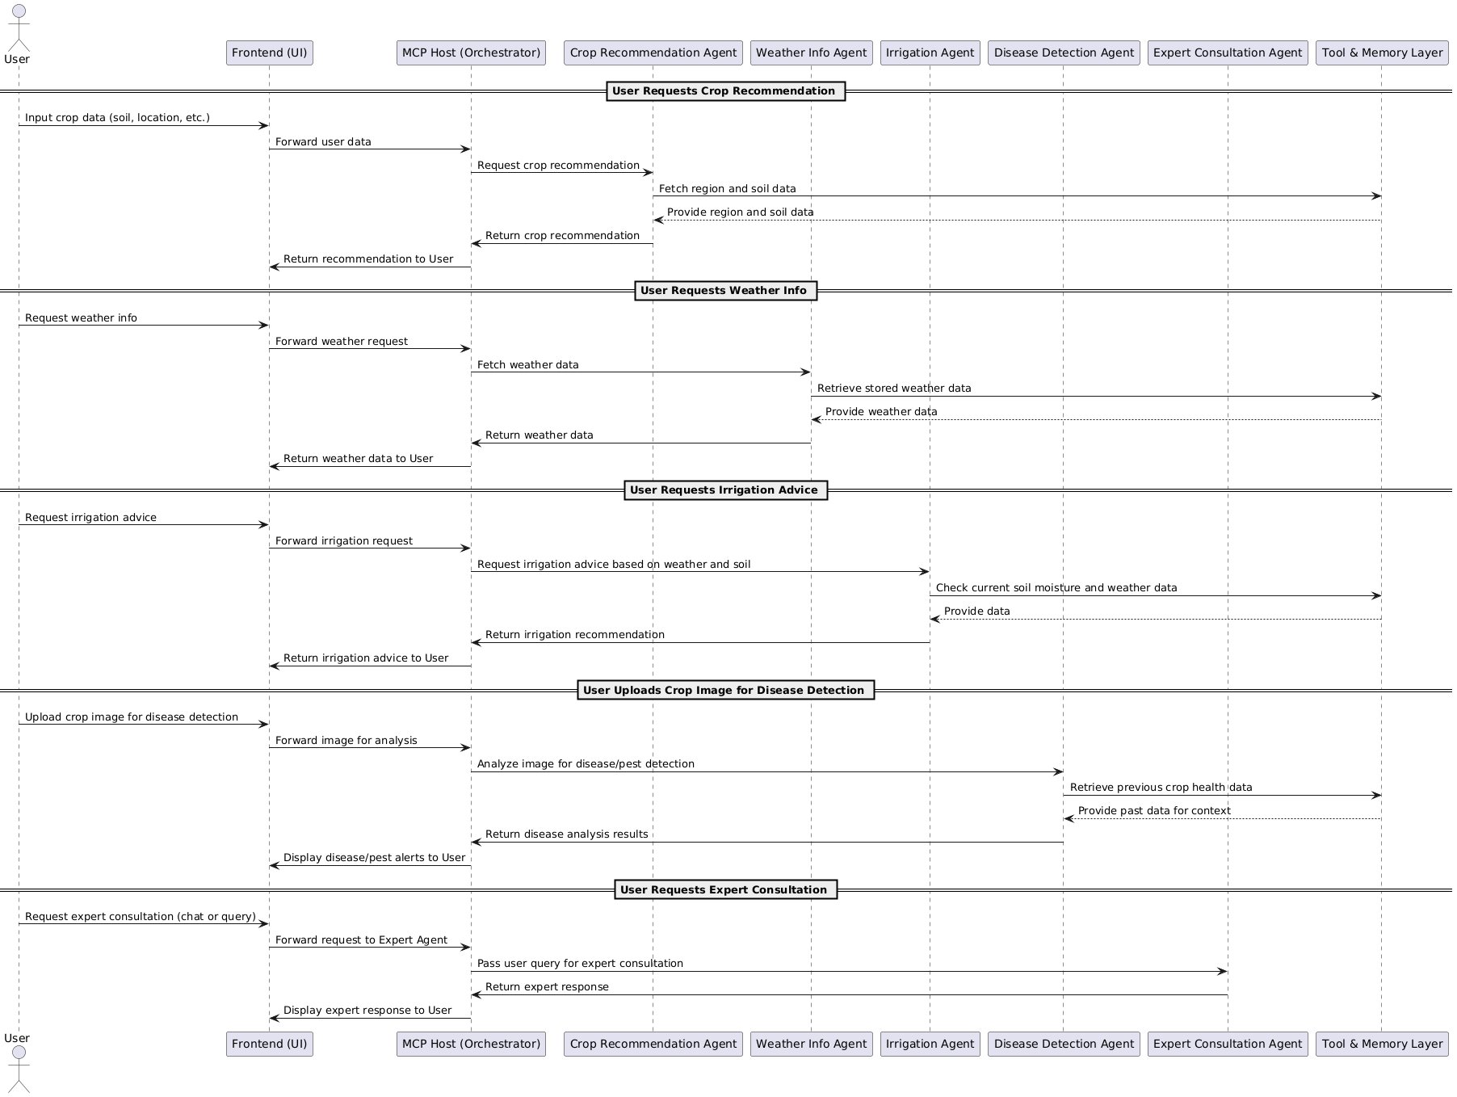
Sequential Diagram :
Drive Link : Link to Image in Drive
References :

YouTube Resources:
Stanford Webinar - Agent AI
Generative vs Agentic AI | IBM Technologies
Types of AI Agents | IBM Technologies
MCP vs API | IBM Technologies

ChatGPT:

Used for searching resources and structuring the report.

